Energy

Energy
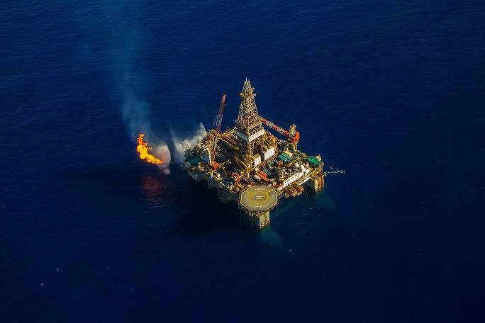

Cyprus is committed to ensuring the security of its energy supply, protecting the environment, fostering healthy competition in the energy sector and encouraging the development of renewable energy technologies and production. Cyprus also aims to positively contribute to
the European energy security of supply.

Cyprus ranks first in the world in solar energy use for water heating in households, and has achieved significant progress in the production of energy from Renewable Energy Sources (RES). The most important projects relating to power generation from RES concern wind parks and photovoltaic parks.

The energy policy of Cyprus is harmonized with that of the European Union. The main aspects of the energy policy include:

• The liberalisation of the electricity and oil markets;
• The establishment and operation of a strategic oil stock terminal;
• The implementation of development programmes related to the use of energy conservation, technologies, the utilization of ingenious RES and the protection of the environment from industrial pollution;
• The RES target is to supply at least 13% of the country’s energy by 2020;
• The promotion of oil products and other sources of environmentally-friendly energy, such as natural gas.

Oil & Gas Sector
The existence of world-class deepwater natural gas reserves in Cyprus Exclusive Economic Zone (EEZ) has attracted a lot of attention from potential international investors, while bringing new and exciting opportunities to the energy sector itself. With the energy developments
in neighbouring countries, the prospects may be there for Cyprus to become an energy hub in the Eastern Mediterranean.

Presently, exploration licenses have been granted for 6 offshore blocks within Cyprus’ EEZ to 3 internationally renowned oil & gas companies and their partners. The Government of Cyprus is continuing its negotiations concerning the infrastructure requirements necessary for bringing the natural gas onshore for local consumption, as well as liquefaction for export into Europe and other markets.

Petroleum Storage and Distribution Terminal
The construction of a private €300m storage and distribution terminal in Cyprus connecting the country with the vibrant trading areas of South East Europe, Asia and North Africa, with a total capacity of 858,000 cubic metres has been completed.

Renewable Energy
Total electricity capacity from RES in Cyprus reached 181 MW in May 2013. The objective, as per the National Action Plan (NAP) issued by the Ministry of Energy, Industry, Commerce & Tourism, is to reach a minimum capacity of 584MW by 2020, which will be equal to 16% of the total electricity production in Cyprus and 3% higher than the target set by the EU.

In this respect, the production of energy from RES is expected to experience considerable growth in the years to come since significant investment is required in order for Cyprus to achieve the targeted capacity as per the NAP.

Relevant Organizations
- Energy Service of the Ministry of Commerce, Industry and Tourism
- CERA - Cyprus Energy Regulatory Authority
- EAC - Electricity Authority of Cyprus
- CIE - Cyprus Institute of Energy

